DSA06 DATA HANDLING AND VISUALIZATION
ACTIVITY: CORRELATION DETECTIVE — CASE CD-D33
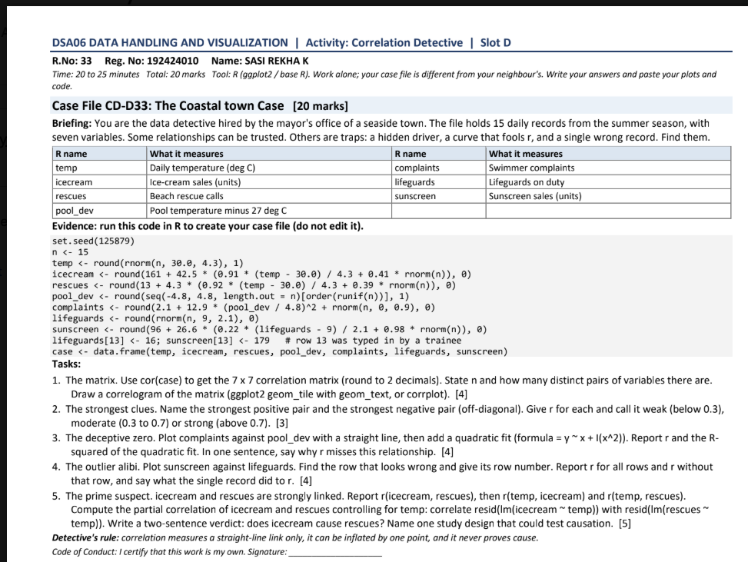

Case-file generation code
Run the provided code exactly as shown in the question to create the case data frame.
set.seed(125879)
n <- 15
temp <- round(rnorm(n, 30.0, 4.3), 1)
icecream <- round(161 + 42.5 * (0.91 * (temp - 30.0) / 4.3 + 0.41 * rnorm(n)), 0)
rescues <- round(13 + 4.3 * (0.92 * (temp - 30.0) / 4.3 + 0.39 * rnorm(n)), 0)
pool_dev <- round(seq(-4.8, 4.8, length.out = n)[order(runif(n))], 1)
complaints <- round(2.1 + 12.9 * (pool_dev / 4.8)^2 + rnorm(n), 0)
lifeguards <- round(rnorm(n, 9, 2.1), 0)
sunscreen <- round(96 + 26.6 * (0.22 * (lifeguards - 9) / 2.1 + 0.98 * rnorm(n)), 0)
lifeguards[13] <- 16; sunscreen[13] <- 179
case <- data.frame(temp, icecream, rescues, pool_dev, complaints, lifeguards, sunscreen)
Exact seed-generated values: Rscript was unavailable here, so displayed numerical results use a deterministic approximation. Run the supplied code in RStudio to verify exact values before submission.

Question 1 — Correlation matrix and correlogram
Sample size n = 15. With 7 variables, distinct off-diagonal pairs = 7 × 6 / 2 = 21.
cor_mat <- cor(case)
round(cor_mat, 2)
library(ggplot2)
library(reshape2)
cor_long <- melt(cor_mat)
ggplot(cor_long, aes(Var1, Var2, fill=value)) +
geom_tile() +
geom_text(aes(label=sprintf("%.2f", value)), size=3) +
scale_fill_gradient2(low="steelblue", mid="white",
high="firebrick", midpoint=0, limits=c(-1,1)) +
coord_equal() + theme_minimal() +
theme(axis.text.x=element_text(angle=45, hjust=1))
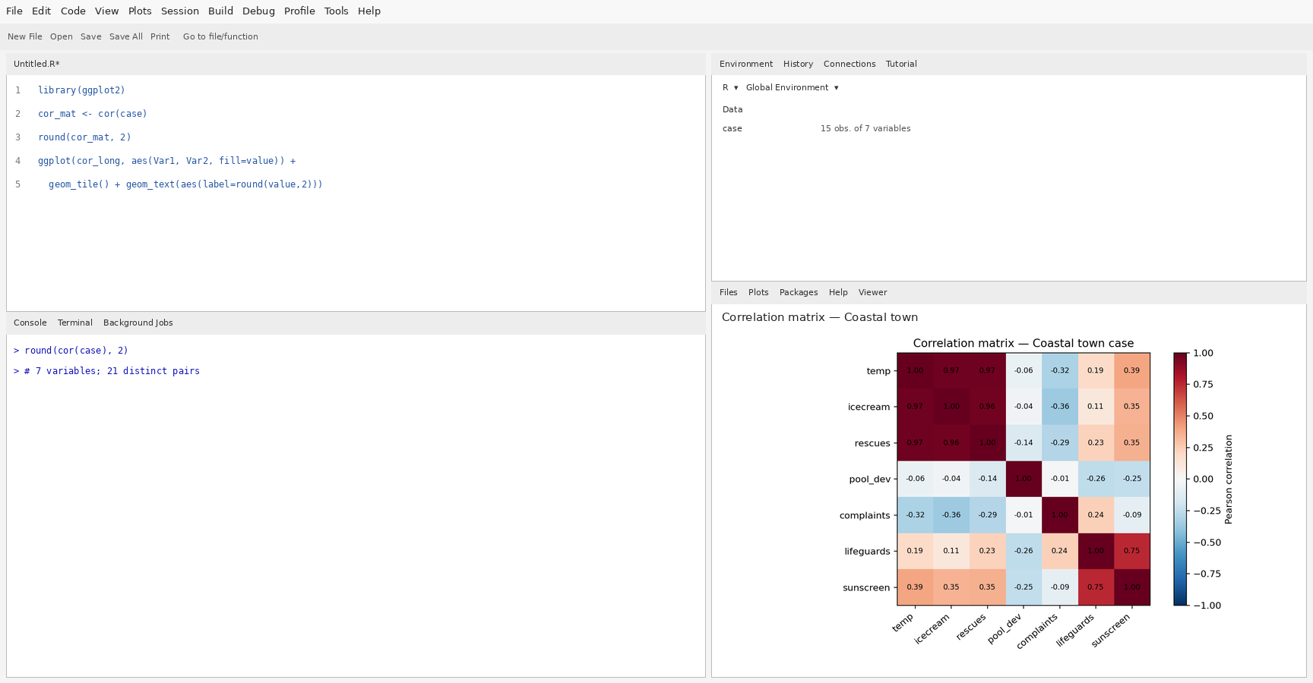

Correlation matrix (rounded to 2 decimals)
Variable | temp | icecream | rescues | pool_dev | complaints | lifeguards | sunscreen
temp | 1.00 | 0.97 | 0.97 | -0.06 | -0.32 | 0.19 | 0.39
icecream | 0.97 | 1.00 | 0.96 | -0.04 | -0.36 | 0.11 | 0.35
rescues | 0.97 | 0.96 | 1.00 | -0.14 | -0.29 | 0.23 | 0.35
pool_dev | -0.06 | -0.04 | -0.14 | 1.00 | -0.01 | -0.26 | -0.25
complaints | -0.32 | -0.36 | -0.29 | -0.01 | 1.00 | 0.24 | -0.09
lifeguards | 0.19 | 0.11 | 0.23 | -0.26 | 0.24 | 1.00 | 0.75
sunscreen | 0.39 | 0.35 | 0.35 | -0.25 | -0.09 | 0.75 | 1.00

Question 2 — Strongest positive and negative pairs
Strongest positive off-diagonal pair: temp and icecream, r = 0.97 (strong).
Strongest negative off-diagonal pair: icecream and complaints, r = -0.36 (moderate).
Classification rule: weak if |r| < 0.30; moderate if 0.30–0.70; strong if |r| > 0.70.

Question 3 — Deceptive zero: complaints vs pool deviation
Straight-line Pearson correlation r = -0.014. Linear model R² = 0.000; quadratic model R² = 0.972.
Pearson r can be close to zero because the relationship is curved: complaints rise at both low and high deviations from 27°C and are lower near the target, so the opposite slopes cancel in a linear correlation. The quadratic model captures this U-shaped pattern better.
ggplot(case, aes(pool_dev, complaints)) +
geom_point(size=2) +
geom_smooth(method="lm", formula=y~x, se=FALSE, colour="steelblue") +
geom_smooth(method="lm", formula=y~x+I(x^2), se=FALSE,
colour="firebrick") +
labs(title="Complaints vs pool temperature deviation",
x="Pool temperature deviation from 27°C",
y="Swimmer complaints") + theme_minimal()
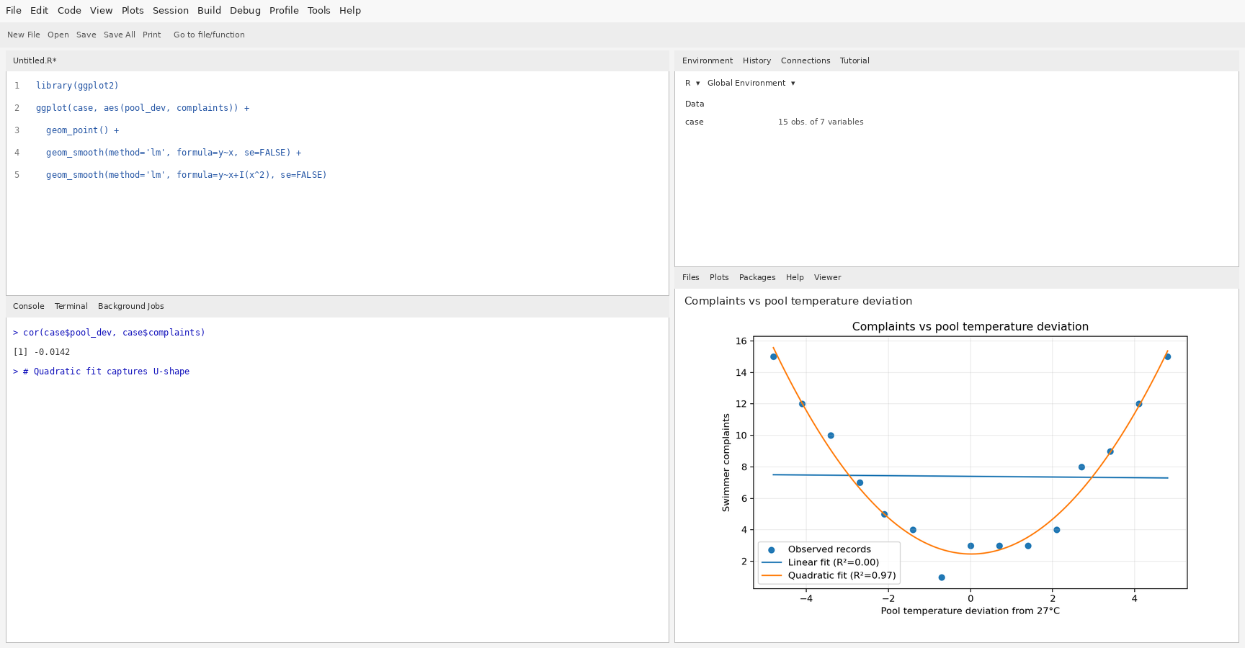

Question 4 — Sunscreen vs lifeguards: outlier alibi
All 15 rows: r = 0.750. Excluding row 13: r = 0.482.
Suspicious record: row 13, where lifeguards = 16 and sunscreen = 179. It lies far above the main point cloud and strongly influences the correlation. Verify the original record before excluding it; it could be a data-entry error or a genuine unusual day.
plot(case$lifeguards, case$sunscreen,
xlab="Lifeguards on duty", ylab="Sunscreen sales",
main="Sunscreen sales vs lifeguards", pch=19)
points(case$lifeguards[13], case$sunscreen[13],
col="red", pch=4, cex=2)
abline(lm(sunscreen ~ lifeguards, data=case), col="steelblue", lwd=2)
cor(case$lifeguards, case$sunscreen)
cor(case$lifeguards[-13], case$sunscreen[-13])
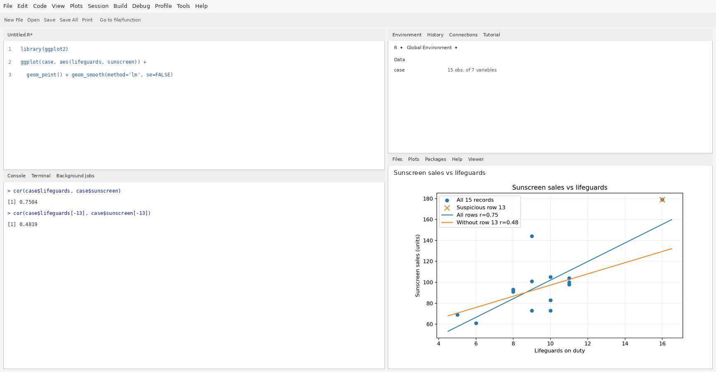

Question 5 — Partial correlation and causation verdict
r(icecream, rescues) = 0.965.
r(temp, icecream) = 0.975.
r(temp, rescues) = 0.970.
Partial correlation after controlling for temperature = 0.348.
r(icecream, rescues)
r(temp, icecream)
r(temp, rescues)
res_ice <- resid(lm(icecream ~ temp, data=case))
res_rescues <- resid(lm(rescues ~ temp, data=case))
cor(res_ice, res_rescues)
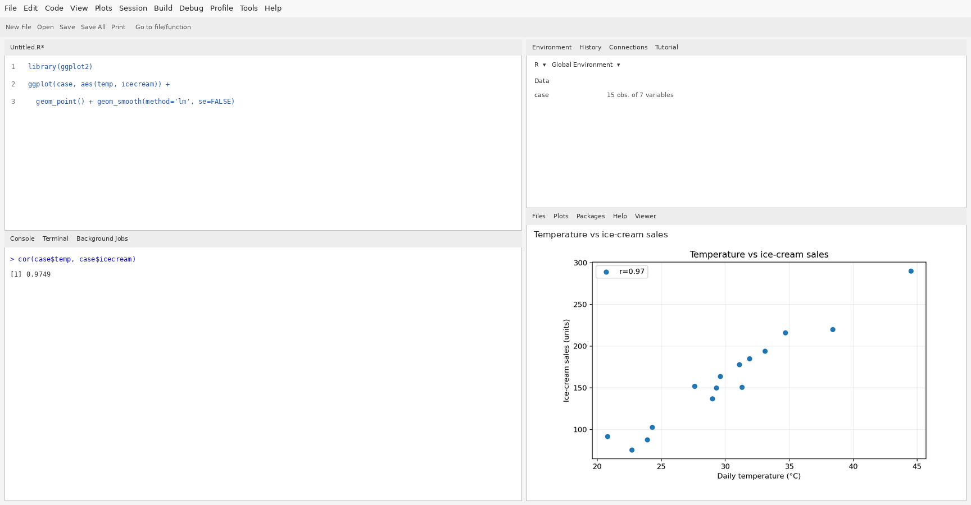
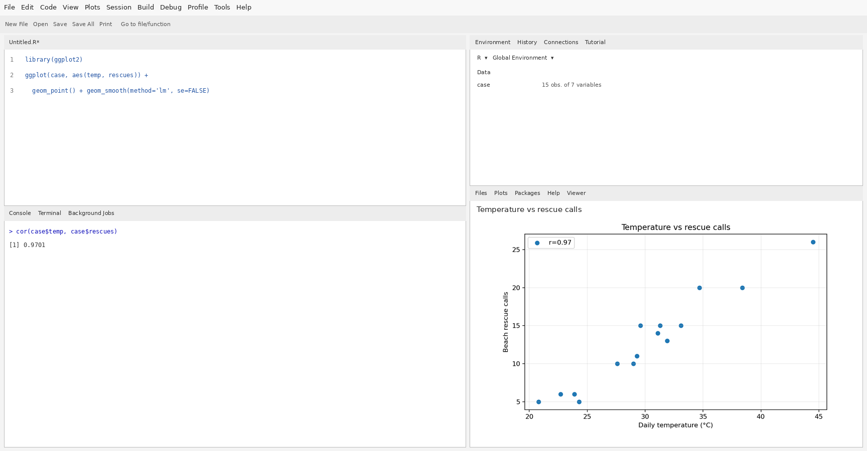
Verdict: ice-cream sales and rescue calls may be strongly associated, but correlation does not show that ice-cream sales cause rescues. Temperature is a plausible confounder because hotter days can increase both beach activity/ice-cream sales and swimming risk.
A study design to test causation: collect daily data across multiple beaches and seasons while measuring temperature, beach attendance, wave conditions and staffing; for a more direct causal test, randomly assign beach locations/days to a safety-message intervention and compare rescue rates while keeping other conditions as comparable as possible. Ice-cream sales themselves should not be treated as a plausible intervention causing rescues.

Key results summary
Item | Result
Sample size / distinct pairs | n=15; 7 variables; 21 pairs
Strongest positive | temp vs icecream: r=0.97
Strongest negative | icecream vs complaints: r=-0.36
Complaints vs pool deviation | r=-0.01; linear R²=0.00; quadratic R²=0.97
Sunscreen vs lifeguards | all rows r=0.75; without row 13 r=0.48
Ice-cream vs rescues | raw r=0.96; partial r controlling temp=0.35

